**Hithesh Shanmugam**

**CSC 481**

**Assignment 7**

**Problem 1. Review of the main topics from image processing *(10/10)***

Briefly describe each one of the topics below. In your descriptions, include the advantages/disadvantages of each approach and an example of an application where the approach can be applied:

1. ***Sampling***

**Definition**: The process of sampling is that to convert the continuous signal into discrete signal likewise in terms of image sampling it is the process of digitizing an image with respect to the coordinate value.

**Application**: Image sensors inside a machine vision camera, Image reconstruction

**Advantages**: The spatial resolution of the digitized image is determined by the sampling rate

**Disadvantages**: By sampling we may lose some data which might be needed and down sampling is an irreversible process

1. ***Quantization***

**Definition**: Image quantization is the process of digitizing the amplitude value of the image

**Application**: Quantization reduces the number of discrete values in the signal which we can use for reduction of number of colors used in image processing

**Advantages**: It enables uniform accuracy and it determines the number of gray levels in a digitalized image

**Disadvantages**: In CNN models the quantized weights make the model hard to converge and also it leads to false contouring

1. ***Histogram equalization***

**Definition**: Histogram equalization is a technique for adjusting image intensities to enhance the contrast of an image this is done by effectively spreading out the most frequent intensity value

**Application**: Used for contrast stretching in an image which can be used in medical images like MRIs etc.,

**Advantages**: If we apply histogram equalization to an image which has low-light some of the non-visible parts are visible in a histogram equalized image.

Disadvantages: It operates independently for each pixel in an image and it is not an effective approach to use it.

1. ***Laplacian of Gaussian (LoG) edge detection***

**Definition**: The second derivative function designed to measure the changes in intensity.

**Application**: For edge detection and to find the edges

**Advantages**: Personally, I felt that it is better than other edge detecting filters in a sense that it was easy to detect the edges in an image

**Disadvantages**: Over sensitive to noise and malfunctions at corners will degrade the magnitude of edges

1. ***Dilation***

**Definition**: Dilation is the process of adding pixels to the boundaries of objects in an image

**Application**: The size of an image can be increased

**Advantages**: It increases the brightness of the object in gray image and it connects the areas that are separated by the space smaller than structuring element

Disadvantages: Increasing the size of the image may not be used in all types of application

1. ***Erosion***

**Definition**: Erosion is the process of removing pixels on object boundaries in an image

**Application**: to remove the unwanted noise in an image

**Advantages**: It is prior to the opening operation rather than the closing operation

**Disadvantages**: There is a loss of data by removing pixels we might lose some of the important pixels

1. ***One topic not in the list above that you enjoyed***

***Color Image Processing***

**Definition**: In color image processing, an abstract mathematical model known as color space is used to characterize the colors in terms of intensity values. This color space uses a three-dimensional coordinate system.

**Applications**: Classification of pictures, Detection of uniform-colored text in video

**Advantages**:Process images in 12 or 14 bits rather than 8 bits available out of the camera for greater accuracy. Automatic adjustments for changing conditions, such as lighting or temperature, to ensure consistency.

**Disadvantages**: It is very much time consuming and more work than the gray image.

**Problem 2. Segmentation overview *(10/10)***

Briefly describe the segmentation techniques learned in this course and the relationships, if any, among them. You can also include a diagram to show the relationships. Pick one of these techniques and describe one application where you think it will be appropriate to use the technique.

**Definition of segmentation:** Image segmentation is a method in which a digital image is broken down into various subgroups called Image segments which helps in reducing the complexity of the image to make further processing or analysis of the image simpler

**Region based segmentation:**

This type of segmentation uses a free-form region that is selected by the model. The selected regions are transformed into predictions at a pixel level to make sure each pixel is visible to computer vision. We use connectivity to prevent connecting different parts of the image.

**Top-down approach:**

At first, we need to define the predefined seed pixel. It can be done by manually choosing the pixels or all the pixels can be chosen as the seed pixel and grow regions until all the pixels belongs to the region.

**Bottom-up approach:**

Instead of all the pixels select only the seeds from object of interest and grow the regions based on a similarity criterion.

**Similarity measures:**

For the grayscale image the similarity measure can be different textures and other spatial properties intensity difference within a region or the distance between mean value of the region.

**Region merging techniques:**

As the name suggests that we try to combine the regions that contain the single object and separate it from the background. There are many regions merging techniques such as watershed algorithm, split and merge algorithm etc.,

**Pros:**

It is faster in performance because it performs simple threshold calculation and region-based segmentation works better when the object and background have high contrast.

**Limitations:**

Computationally expensive and sensitive to noise. It is a local method without any global view of the problem.

**Histogram based segmentation:**

One of the most widely applied techniques for image segmentation is histogram-based segmentation, which assumes that homogeneous objects in the image manifest themselves as clusters. The key to the histogram-based technique is the selection of a set of thresholds that can discriminate objects and background pixels

**Selecting Threshold**

Automatic thresholding

P-tile method

Mode method

Peakiness detection

Iterative algorithm

**Limitations of histogram segmentation:**

Use GLOBAL information

Ignore SPATIAL relationships among pixels

**Problem 3. *(10/10)***

The image in Figure 1(a) below shows a gray level image. The images in the other parts correspond to low-passed, high-passed, or band-passed version of (a), not necessary in that order. Identify which of the images in (b), (c), and (d) is low-pass, which one is band-passed, and which one is high-passed? Justify your choices.

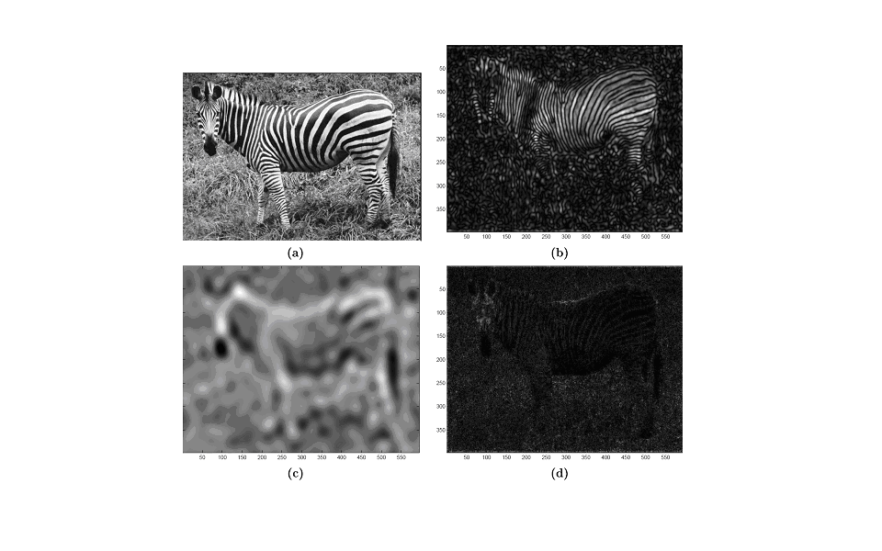

Figure 1: Figure for Problem 2

(b) ***LOW PASS IMAGE*** because low frequency details are passed and diminishes the high frequency details

(c) ***HIGH PASS FILTERS*** as it allows the high frequency to pass and reduces the low frequency

(d) ***Bandpass filters:*** This filter allows signals with a particular bandwidth to pass and diminishes the frequencies below and above a certain threshold

**Problem 4. *(10/10)*:**

Describe an algorithm to locate all of the large boxes in the image (Figure 2) below.



Figure 2: Image for Problem 4

Step 1: Scan the image for visible boxes which might be present.

Step 2: Detect the edges of the boxes found {

Step 3: Label the corners of the boxes {Follow the border of the boxed in the dark and light areas with a pen}

Step 4: In labeling the corners one more thing that can be done is to determine the coordinates of the corner and this can be accomplished by marking the spots present on box borders at which the borders connect with each other.